How to Run Excel Marcos Guide

There are two ways to run any excel Macros.

If you are choosing method 1 you will be required repeats the steps all the time whenever you open a new excel book.

Method 2 will only need to set up it once all excel book will have access to the macro.

However both ways will required you to have the **Developer** Tab enable in Excel. Highlighted in Fig 1.

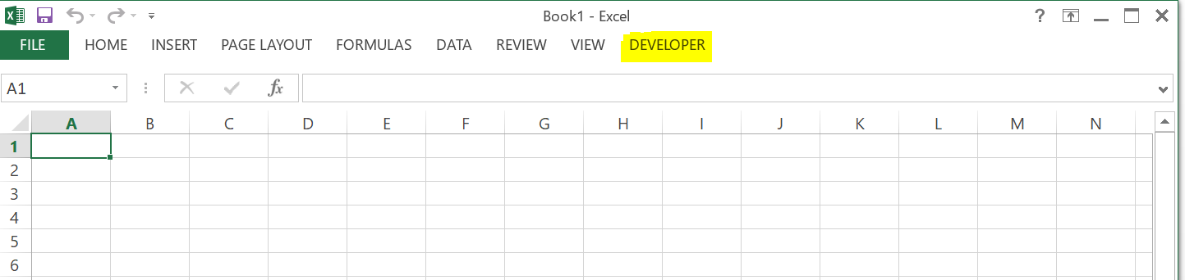

Fig 1

If you do not have the Developer tab enable like the following figure: Fig 2

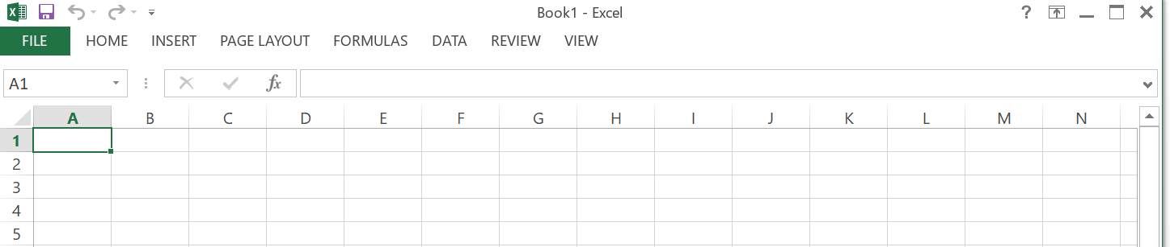

Fig 2

Please follow the following steps to enable it.

* Click on **File** Tab
* Then find and click on **Options**
* Find and click on **Customize Ribbon**
* Find and Check off the **Developer**
* Click on **Ok**.

Here is some pictures illustration:

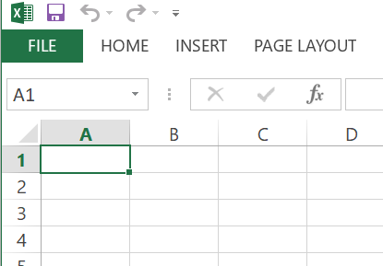

Step 1

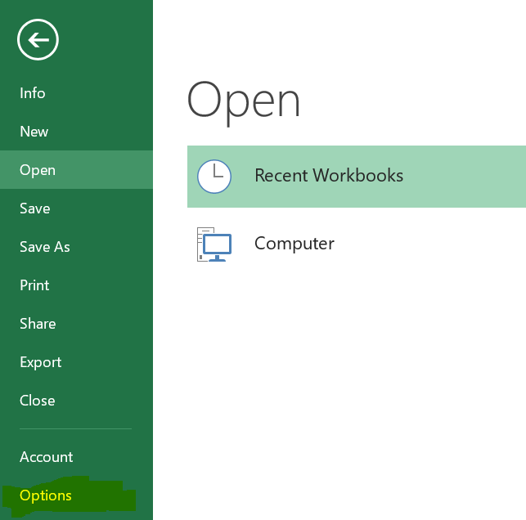

Step 2

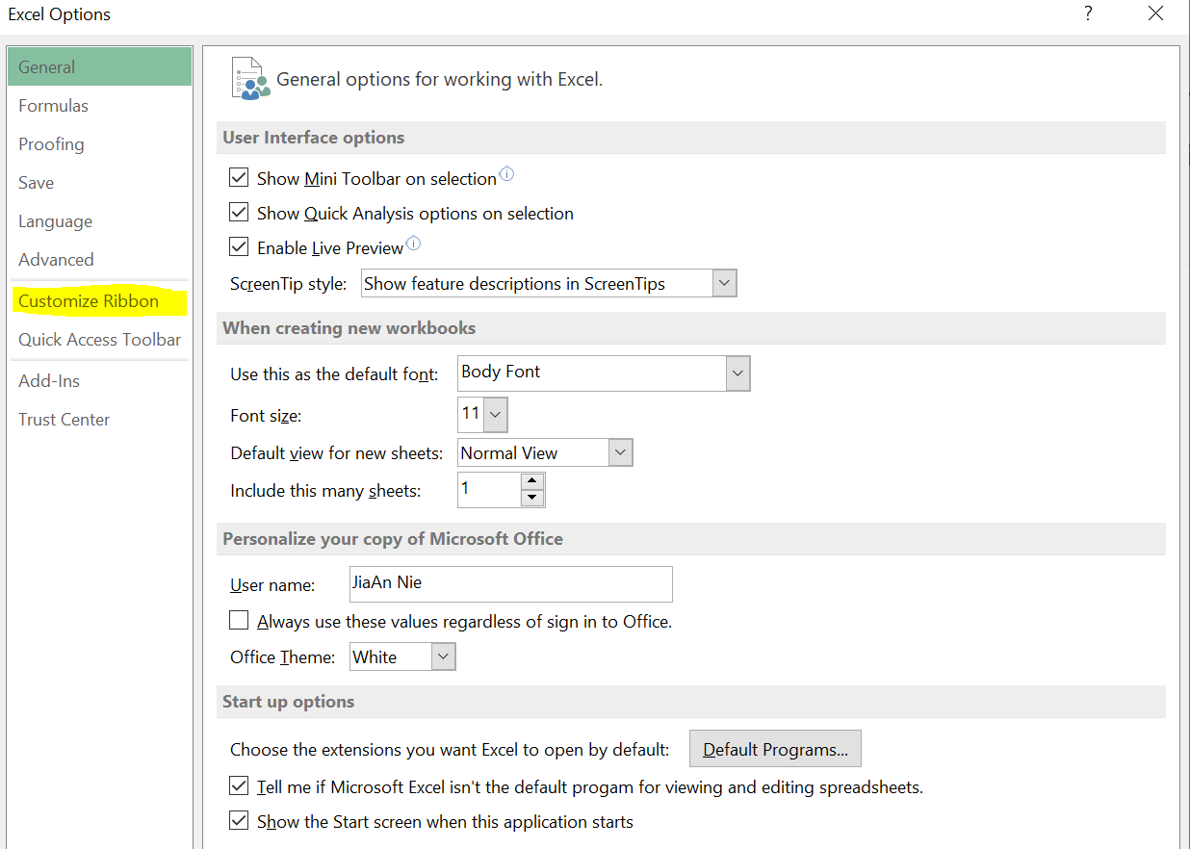

Step 3

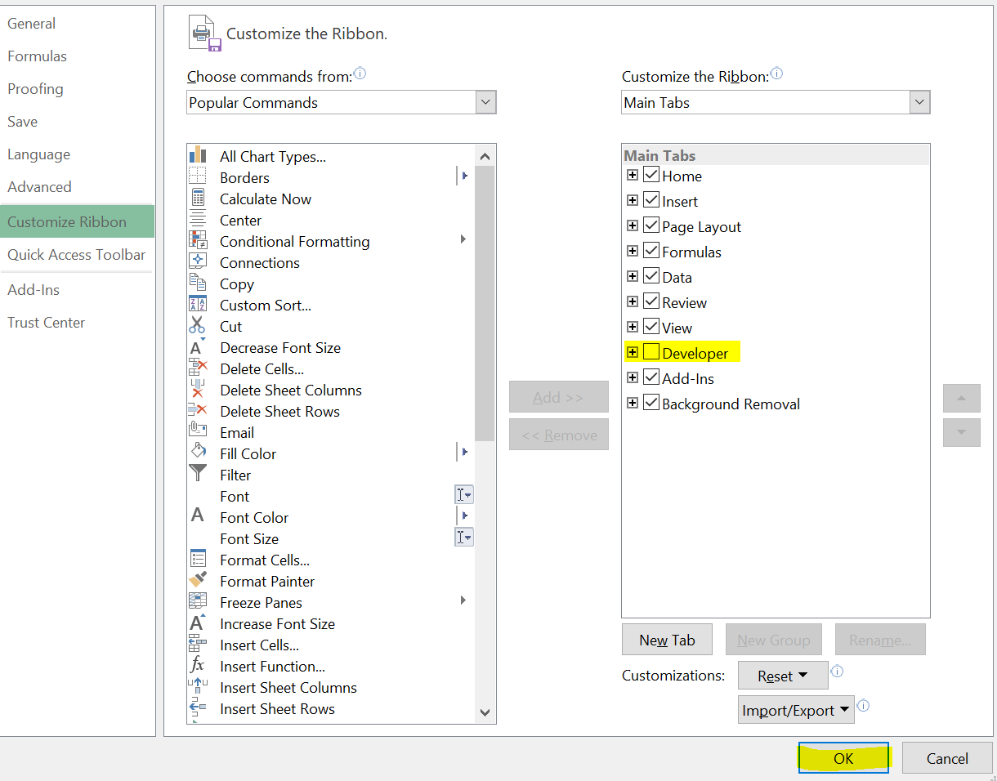

Final Step for enable Developer Tab

Method 1: Copy and Paste the code and run the Macro

1. Click on the Developer Tab that you have enabled
2. Click on the Visual Basic Icon
3. You will be greeted by a code editor

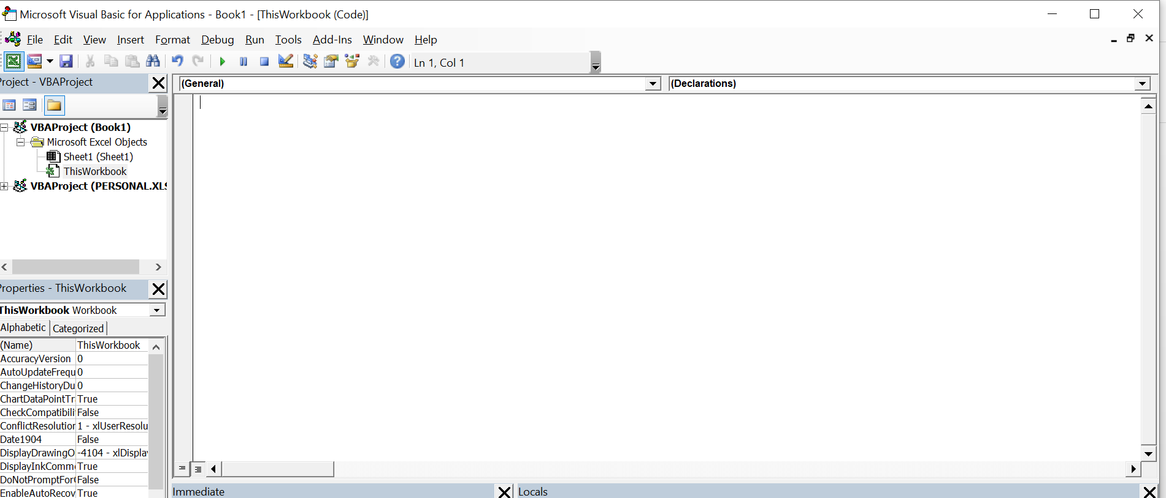

1. Open the macro you wanted to run in Notepad
2. Select everything and copy
3. Go back to the code editor
4. Paste it into “ThisWorkbook” tab
5. Find “run” button and click on it to run the macro

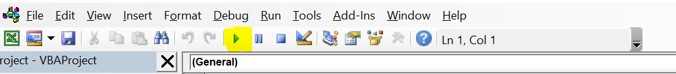

1. Once you run the code go back to excel to double check the result

Method 2: Creating shortcut and bind it to the Macro.

1. Click on the Developer Tab that you have enabled
2. Find and Click on Record Macro

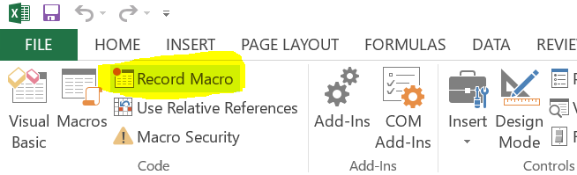

1. Once you click on the Record Macro you will be greeted with the following screen.

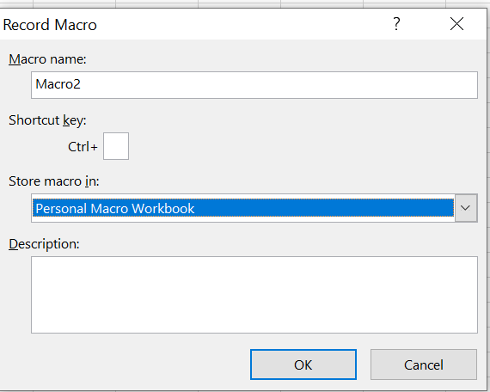

1. On this screen the only thing you want to make sure is under the “Store macro in: ” make sure is selected the Personal Macro Workbook. If that is the case you can press OK

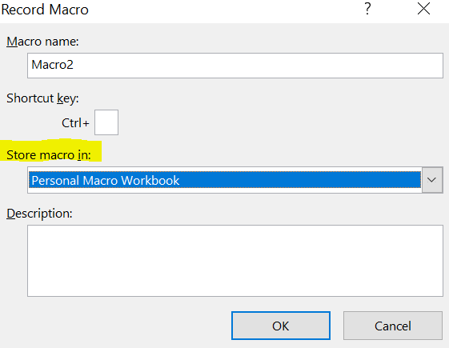

1. Then Click on the developer tab and Click on the “Stop Recoding “

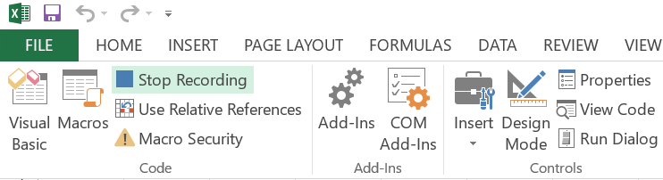

1. Then if you click on Developer Tab and click on “Macros” you will be greeted by the following pop up window.

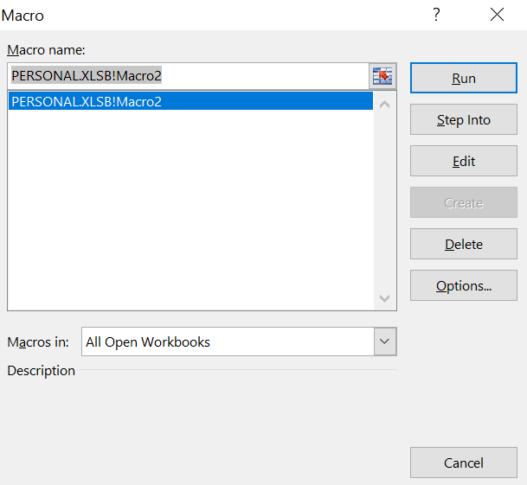

1. Click on the “Step Into” button a window will pop up like the following:

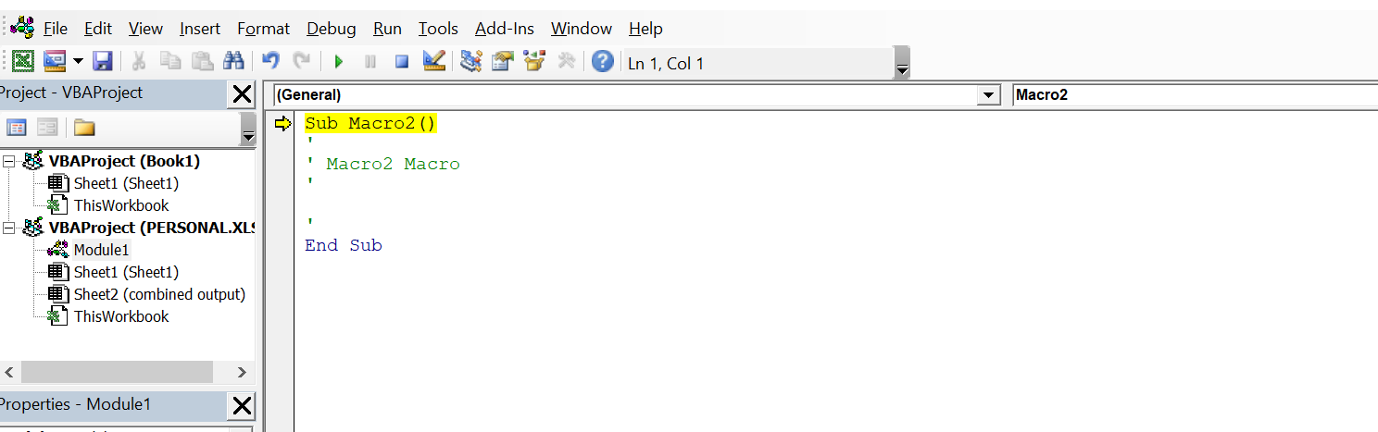

1. Next Click on the Square button highlighted on the following image:

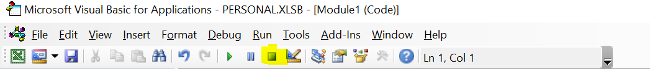

1. Remove all text. Your screen should look something like the following

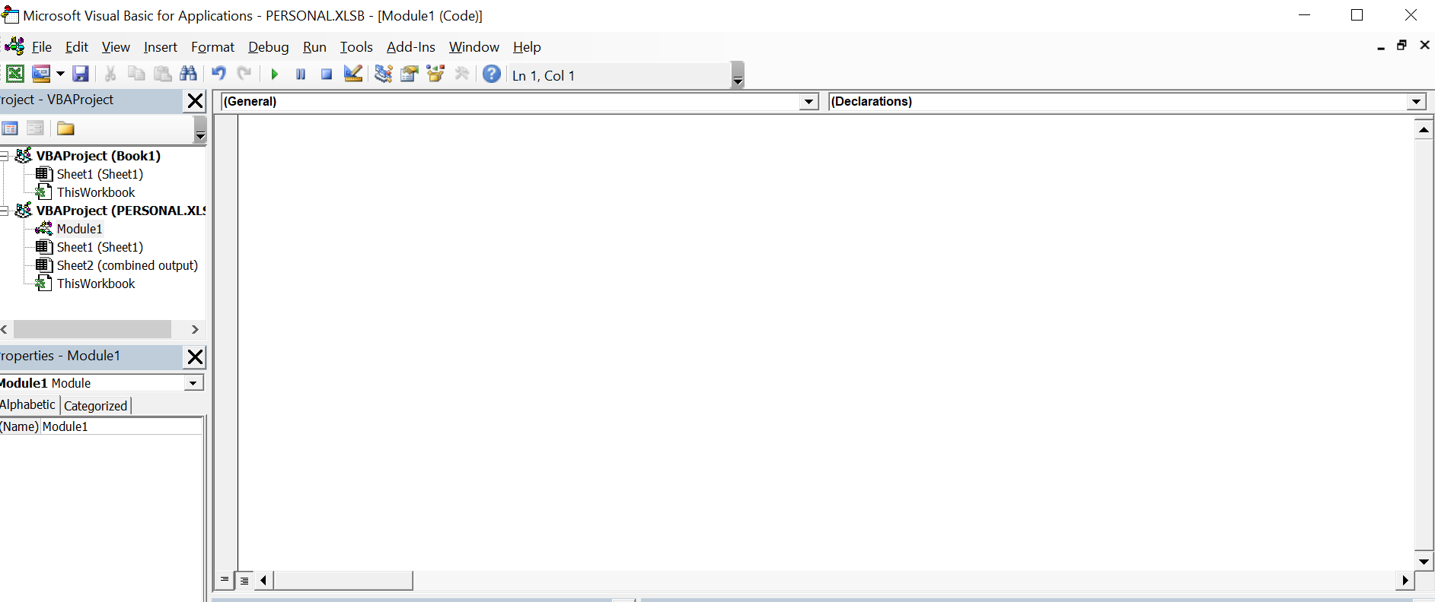

1. On the Left hand side make sure “Moduel1” is being highlighted. Because this is the place where you want to copy and paste the code into.

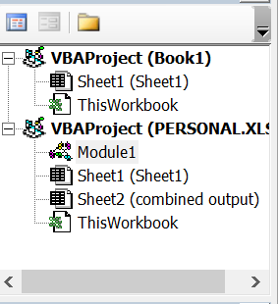

1. Copy and Paste the code into window.

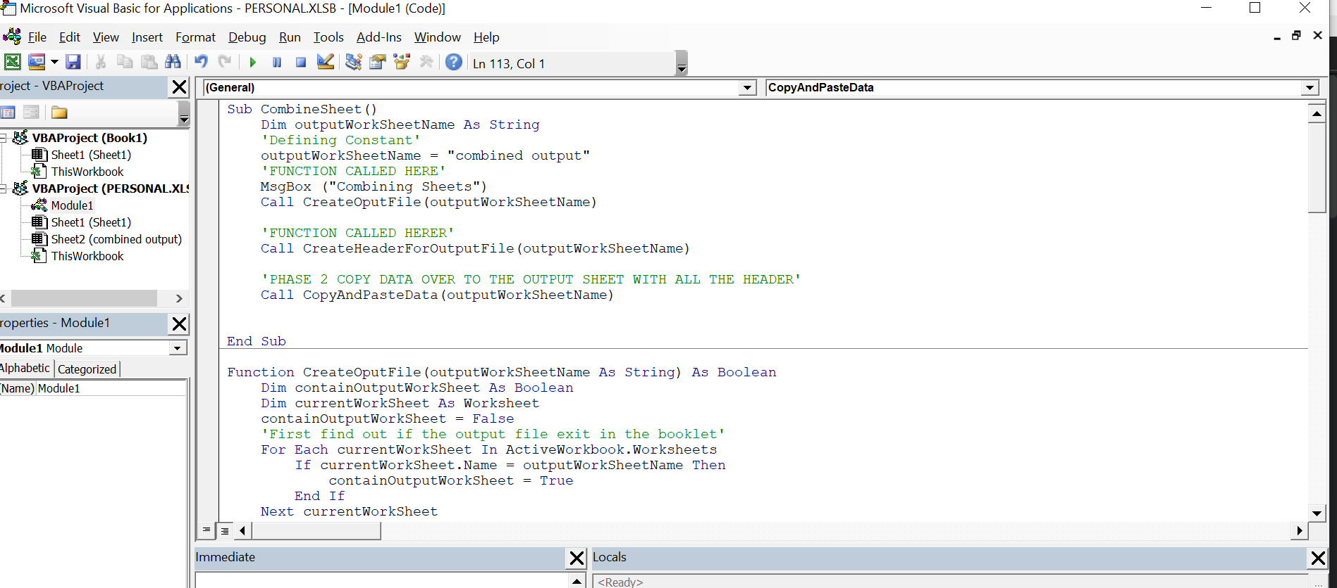

1. Save the file by File-> Save PERSONAL.XLSB or press Ctrl S and close the window

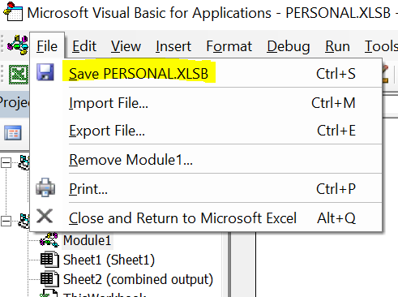

1. If you Click on Developer Tab -> Macros you can run that macros anytime

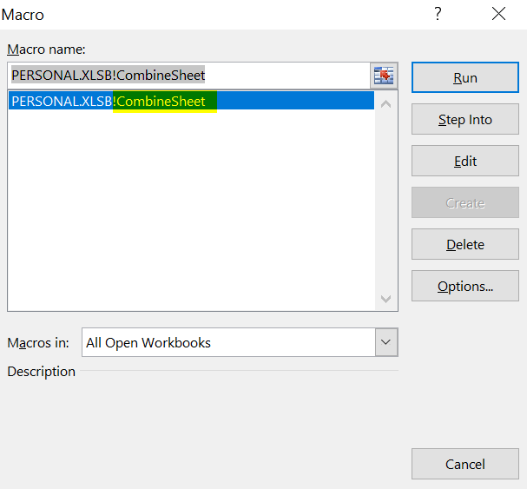

1. (Optional Recommended) Click on Options

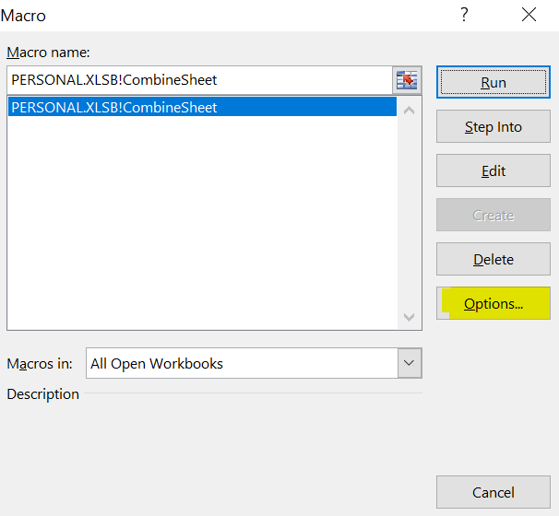

1. (Optional Recommended) you will be have this pop up window

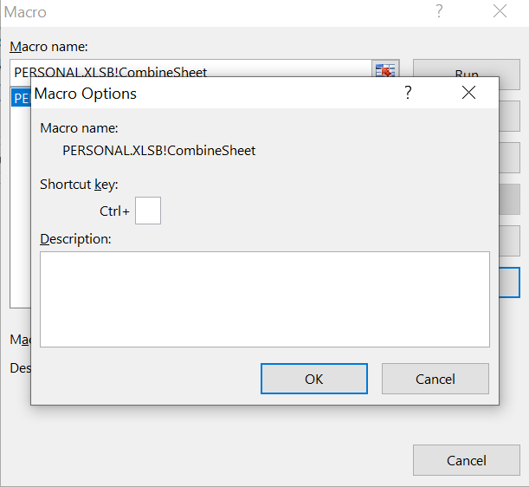

1. The purpose of this step is allow you to make your own shortcut when you run the copy and pasted macro. So If you click on the input field near the “Ctrl +” enter a character in ie: “p”,

Whenever you want run the macro instead of by clicking “Developer tab-> Macros …” you can simply press “Ctrl p” to run the macro